Our Ref: _______________ Your Ref: ________________________ Date: __________________

Baptist Church

Baale Yaku Site Area, P. O. Box 644,

Ogbomoso, Oyo State. Tel. 07052425407

Email: [newsprinbaptistchurch@gmail.com](mailto:newsprinbaptistchurch@gmail.com)

Website: newspringbc.comze.com

NEW SPRING

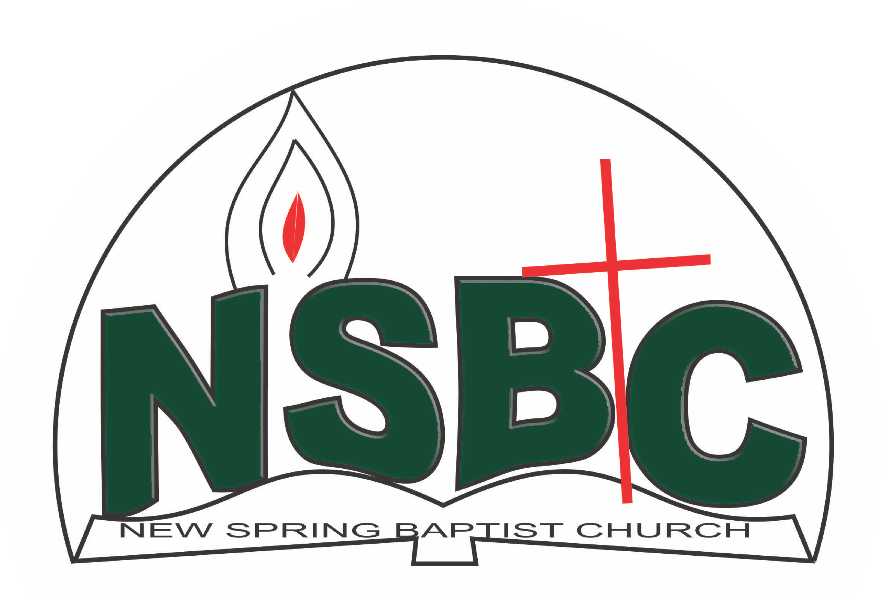

December 27, 2021

Dear Mrs.Bose Ayinde,

Nomination to Serve as a Worker in the Church in 2022.

Calvary greetings in the precious name of our Lord and Saviour Jesus Christ. It is our pleasure to inform you that at the Church-in-Conference held on December 19, 2021, the Church ratified your nomination to serve in the following areas between January 1 and December 31,2022:

1. President, Women Missionary Union(WMU)
2. Member, Benevolence Committee under the leadership of Dn. Dele Olatubosun
3. Member, Membership Committee under the leadership of Mr. Johnson Olaniran
4. Member, Nominating Committee under the leadership of Dn. Ayinde Ezekiel
5. Member Mission and Evangelism under the leadership of Dn. Ayinde Ezekiel
6. Member, Church Council

Please refer to the table below for the key functions of each of these roles. Details can be found in the Church constitution. You are strongly encouraged to become familiar with the tasks as stated in the document. There will be an orientation of the Church workers on January 15, 2022 at 8:30 a.m. on the church premises. Please ensure you participate in this training.

“Now it is required that those who have been given a trust must prove faithful. I Corinthians 4:2”. May God find you faithful in the task He has assigned to you.

| Domain | Key function of Office, Department or Committee |
| --- | --- |
| President,WMU | To provide support to the Church Pastor in ensuring that the mission of women as co-labourers with God is effectively implemented in the Church **and** be responsible for the efficient running of the Union – The Women Missionary Society (WMS), The Lydia, The Girls’ Auxiliary (GA). and The Sunbeam. |
| Benevolence Committee | The committee is responsible for the implementation of the benevolence policy of the Church. |
| Member, Membership Committee | Responsible for the overall management of the membership of the Church |
| Nominating Committee | The Nominating Committee shall coordinate the staffing of all Church leadership positions that are filled by volunteers |
| Member, Mission & Evangelism Committee | Responsible for the mobilization of Church members for soul winning activities. |
| Member, Church Council | The Church Council is the governing body of the Church whose membership, under the leadership of the Holy Spirit, holds one another mutually accountable with respect and love and sees to the smooth running of the Church. |

Thank you for accepting to serve in this Church.

Yours in His service

Olusayo Okediji Blessed Agboola

Church Secretary Chairman, Nominating Committee